**PROJECT PROPOSAL**

*The kind of data you'd like to work with and the field you're interested in (e.g., trading, quantitative analysis).*

*The kinds of questions you'll be asking of that data.*

*Possible source for such data.*

Our project seeks to develop a trading application that helps to develop trading strategies based on real-time pricing data for options, stocks, ETF, bonds and cryptocurrencies.

Product features:

* develop API feeds with relevant option pricing and stock profile
* user can select and analyze individual option positions and underlying stock profile
* each option position shows bid-ask for call and put options with different strike prices around the current stock price
* current stock profile includes stock price, market cap, 52 week high/low
* additional option info: OTM %, premium % of stock price, $ premium for 1 option contract
* generate Monte Carlo simulations
* user chooses type of trading strategy: long
* Compute **Implied volatility** based on Option price, strike price current price and Rate (using either black schole model or Numerical model or Numerical method like Montecarlo or Binomial Tree Model)
* **Option Chain Screen:**
* 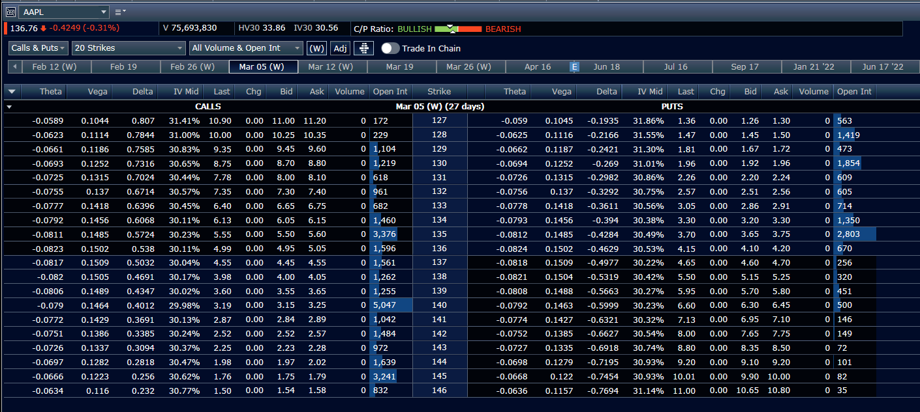

**Stock Description & Stats Screen:**

